MARS AVATAR PROJECT
Control Without Presence
Concept White Paper
v3.0
A conceptual study of a telepresence architecture
for the remote exploration of Mars

Table of Contents
Chapter 1. Introduction 3
Chapter 2. The Challenge of Exploring Mars 5
Chapter 3. Mars Avatar Project Architecture 8
Chapter 4. Artificial Intelligence as the System Core 12
Chapter 5. Interplanetary Communication and Mission Control 17
Chapter 6. Robotic Avatars 21
Chapter 7. Human–Machine Interface: From Traditional Control to Telepresence 27
Chapter 8. Implementation Roadmap (Technology Roadmap) 31
Chapter 9. Analysis of Risks, Limitations, and Ethical Aspects 35
Chapter 10. Conclusion and Outlook 39
Appendix A. Sources and References 42

Chapter 1. Introduction

1.1 Introduction
Humanity is entering a new era of space exploration. Over the past decades, robotic missions have significantly expanded our knowledge of the Solar System, and automated spacecraft have proven their effectiveness in exploring the Moon, Mars, asteroids, and other celestial bodies.
Despite these successes, crewed expeditions beyond near-Earth space remain extremely challenging. Long-duration flights require protecting the crew from cosmic radiation, building reliable life-support systems, addressing the medical problems of prolonged weightlessness, and ensuring a safe return to Earth. These factors substantially increase the cost, complexity, and risk of such missions.
At the same time, robotics, artificial intelligence, computer vision, autonomous navigation, and human–machine interfaces are advancing rapidly. Together, these technologies open up the possibility of considering a different approach to planetary exploration.
This document presents the concept of the Mars Avatar Project — an architecture in which the human retains key decision-making authority, while intelligent robotic avatars provide physical presence on the surface of Mars. In such a system, autonomous algorithms compensate for the inevitable communication delay between Earth and Mars by carrying out local actions within the goals set by the operator.
It is important to emphasize that this document is not a proposal for a ready-made space mission. It is a conceptual study whose purpose is to propose a coherent roadmap for the technologies required by such an architecture. The work deliberately distinguishes between:
- existing technologies;
- projected directions of development;
- long-term research hypotheses.
This approach allows the idea to be discussed in an engineering context without conflating the proven capabilities of current technology with more distant scientific prospects.

1.2 Purpose of the Document
The purpose of this White Paper is to present a conceptual architecture for a telepresence system for exploring Mars, bringing together advances in robotics, artificial intelligence, space communication, and human–machine interfaces.
The document seeks to answer the following questions:
- Which technologies already make it possible to implement individual elements of such a system?
- Which engineering problems remain unsolved?
- What is a realistic development path for such technologies over the coming decades?
- What are the advantages and limitations of an approach based on robotic avatars?

1.3 Scope of Application
The proposed architecture can be considered for a range of scenarios:
- scientific research on the surface of Mars;
- construction of automated infrastructure;
- preparation for future crewed missions;
- equipment maintenance;
- resource extraction;
- exploration of other planets, moons, and asteroids.

Chapter 2. The Challenge of Exploring Mars

2.1 Why Mars?
Mars remains one of the most attractive targets for human exploration. Compared with other objects in the Solar System, it offers a number of advantages: a day length close to Earth's, the presence of an atmosphere (albeit a very thin one), reserves of water ice, and significant scientific potential.
Exploring Mars can help answer fundamental questions about the origin of planets, the evolution of climate, and the possibility of life beyond Earth. In addition, the experience gained could form the basis for future expeditions to more distant objects in the Solar System.
However, Mars remains an extremely challenging environment for humans to work in.

2.2 Main Engineering Challenges

Cosmic Radiation
Beyond Earth's magnetic field, a crew is exposed to galactic cosmic rays and solar energetic particles.
Even with modern protective measures, prolonged time in interplanetary space increases health risks, including the likelihood of cancer, damage to the nervous system, and other long-term effects. [1][2][3]
For robotic systems this problem is substantially less critical, since they do not require biological protection and can be designed with radiation-hardened electronics.

Mission Duration
A typical crewed expedition to Mars can last more than two years, accounting for the outbound flight, the wait for a favorable return window, and the return trip.
Throughout this time it is necessary to provide:
- food;
- water;
- oxygen;
- medical care;
- psychological support;
- maintenance of life-support systems.
Every additional day increases the complexity of the mission.

Limits of Human Capability
Even after a successful landing, humans face serious limitations:
- fatigue;
- the need for rest;
- limited duration of extravehicular activity;
- the effects of reduced gravity;
- the risk of errors under high workload.
Robotic systems also have limitations, but they can operate far longer without breaks, provided they are supplied with power and maintenance.

2.3 Communication Delay
One of the key engineering challenges is the distance between Earth and Mars.
Depending on the relative position of the planets, a signal takes roughly 4–22 minutes to travel one way. [4][5] This means that direct real-time control of a robot is impossible.
For example:
- the operator presses a button;
- the command reaches Mars several minutes later;
- the robot performs the action;
- confirmation returns several minutes after that.
The full cycle can take tens of minutes.
Consequently, the traditional teleoperation model is not suitable for interplanetary missions.

2.4 Why Isn't It Enough to Simply Increase the Speed of the Link?
No advance in data-transmission technology can remove the fundamental limitation imposed by the speed of propagation of electromagnetic waves.
Even a perfect link is bound by the speed of light. The architecture of future systems must therefore treat the inevitable delay as a basic physical condition rather than a temporary engineering problem.
This leads to the necessity of autonomous algorithms capable of carrying out local actions without continuous human involvement.

2.5 Cost of Crewed Missions
Crewed expeditions require complex systems:
- heavy launch vehicles;
- landing modules;
- living quarters;
- resource reserves;
- crew protection systems;
- return vehicles.
Each of these components substantially increases the cost of the program.
Robotic missions also require significant investment, but they do not need life-support systems and can be specialized for specific tasks, which potentially allows more flexible scaling of infrastructure.

2.6 Framing the Problem
Given these constraints, a question arises:
Can a system be built in which the human retains intellectual control of the exploration, while physical presence on the surface is provided by a network of autonomous robotic avatars?
This document treats this idea as a conceptual architecture that combines current advances in robotics, artificial intelligence, and space communication. The goal is not to replace future crewed missions, but to explore whether such an approach could complement them by improving the safety, flexibility, and efficiency of Mars exploration.

Chapter 3. Mars Avatar Project Architecture

3.1 General Concept
The Mars Avatar Project is based on the principle of "Control Without Presence" — control without physical presence.
Unlike the traditional model of crewed expeditions, in which the human personally performs every action on the surface of the planet, the proposed architecture separates intellectual presence from physical presence.
The human remains the source of goals, decisions, and scientific analysis, while the robotic system provides direct interaction with the environment.
In this way, intelligence remains on Earth, while physical presence is projected onto Mars through autonomous robotic platforms.

3.2 System Architecture
The concept comprises seven interconnected layers, shown in the diagram below.
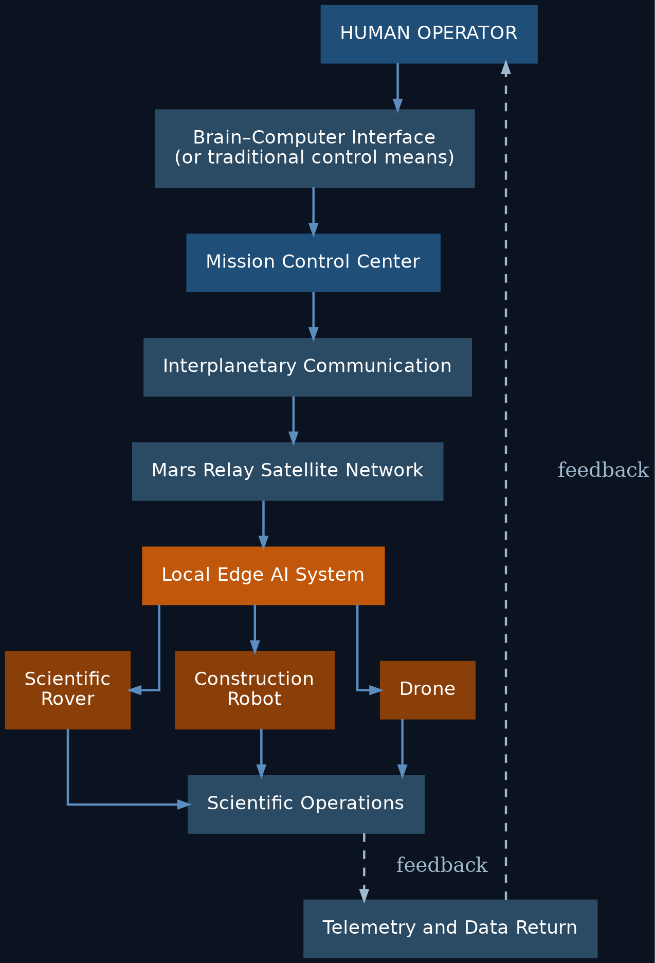
Fig. 3.1. Architectural diagram of the Mars Avatar Project system

3.3 The Human Layer
The human remains the central element of the entire system. The human:
- defines the scientific objectives;
- selects priorities;
- approves critical decisions;
- analyzes the results obtained;
- intervenes in non-standard situations.
The AI does not make strategic decisions on its own.

3.4 Control Interface
In the early stages, traditional tools are used:
- computer;
- VR;
- AR;
- joysticks;
- voice control.
As technology develops, brain–computer interfaces (BCI) may be used, enabling faster and more convenient interaction with the system.
It is important to note that, for the foreseeable future, BCI is regarded as a supplement rather than a mandatory component.

3.5 Mission Control Center
Mission Control brings together all elements of the system. Its functions:
- task planning;
- priority management;
- resource allocation;
- supervision of multiple avatars;
- processing of scientific information;
- interaction with operators.
It is, in effect, the intelligent dispatcher of the entire expedition.

3.6 Interplanetary Communication
Information is transmitted via existing or future deep-space communication networks. Main functions:
- command transmission;
- telemetry transmission;
- system state synchronization;
- data integrity verification;
- encryption.
The architecture assumes the use of relay satellites in Mars orbit to improve communication reliability. [6][7]

3.7 Local Artificial Intelligence
This is the key element of the entire concept. Because of the signal delay, it is the local AI that makes decisions within the bounds of the assigned task.
For example, the operator sends the command:
"Collect a rock sample near the crater."
The AI then independently:
- plans a route;
- avoids obstacles;
- maintains the robot's stability;
- selects the collection site;
- assesses safety;
- performs the manipulation;
- returns a report to the operator.
The human defines the goal. The AI determines how to achieve it within the given constraints.

3.8 Robotic Avatars
The architecture calls for the use of specialized platforms.

Scientific Rover
- geology;
- soil analysis;
- ice prospecting;
- sample collection.

Construction Robot
- construction;
- equipment installation;
- cable laying;
- site preparation.

Drone
- reconnaissance;
- mapping;
- inspection of objects;
- search for safe routes.

Laboratory Unit
- chemical analysis;
- biological research;
- sample preparation.

Cargo Robot
- equipment transport;
- material delivery;
- logistical support.

3.9 The Goal-Based Control Principle
Traditional robotics operates with low-level instructions:
Turn right. Drive 20 meters. Raise the arm. Lower the arm.
The Mars Avatar Project proposes a different approach — framing tasks at the level of goals:
Survey this area. Collect the most interesting sample. Build a solar array. Inspect the station.
Once a goal is received, the local AI independently breaks it down into a sequence of actions. This approach makes the system resilient to large communication delays.

3.10 Scalability
The architecture is designed as a modular system capable of growing from a single operator and vehicle to a distributed research infrastructure:
- Today: 1 operator → 1 robot
- In the near term: 1 operator → Mission AI → 10 specialized robots
- In the long term: a science team → Mission Control → hundreds of autonomous platforms
This makes it possible to gradually expand the research infrastructure without fundamentally changing the architecture.

3.11 Chapter Conclusions
The proposed architecture is based on a division of roles between human and machine.
The human retains responsibility for goals, scientific decisions, and mission control.
The local artificial intelligence provides autonomous execution of tasks under an unavoidable communication delay.
Robotic platforms become the physical extension of human research activity, expanding humanity's presence in space without requiring the crew to remain continuously on the Martian surface.

Chapter 4. Artificial Intelligence as the System Core
“Artificial Intelligence does not replace the human operator. It extends the operator's ability to act across interplanetary distances.”

4.1 Why AI Is Necessary
The main constraint on interplanetary control is not computing power and not the bandwidth of the communication channels.
The main constraint is the speed of light.
Even with a perfect link between Earth and Mars, an operator could not control a robot the way a surgeon controls a robotic system in the next room. A signal delay of several minutes rules out continuous manual control.
For this reason, artificial intelligence within the Mars Avatar Project is treated not as a replacement for the human, but as a mandatory element of the architecture, providing autonomous execution of local actions.

4.2 Philosophy of the AI Assistant
The project is built on the Human-in-the-Loop principle. This means:
- the human defines the goals;
- the human sets the constraints;
- the human approves critical actions;
- the AI independently carries out the assigned task.
This approach preserves human control over the mission while compensating for the unavoidable communication delays.

4.3 Artificial Intelligence Architecture
The AI consists of several independent modules, each responsible only for its own domain. This reduces overall system complexity and increases reliability.
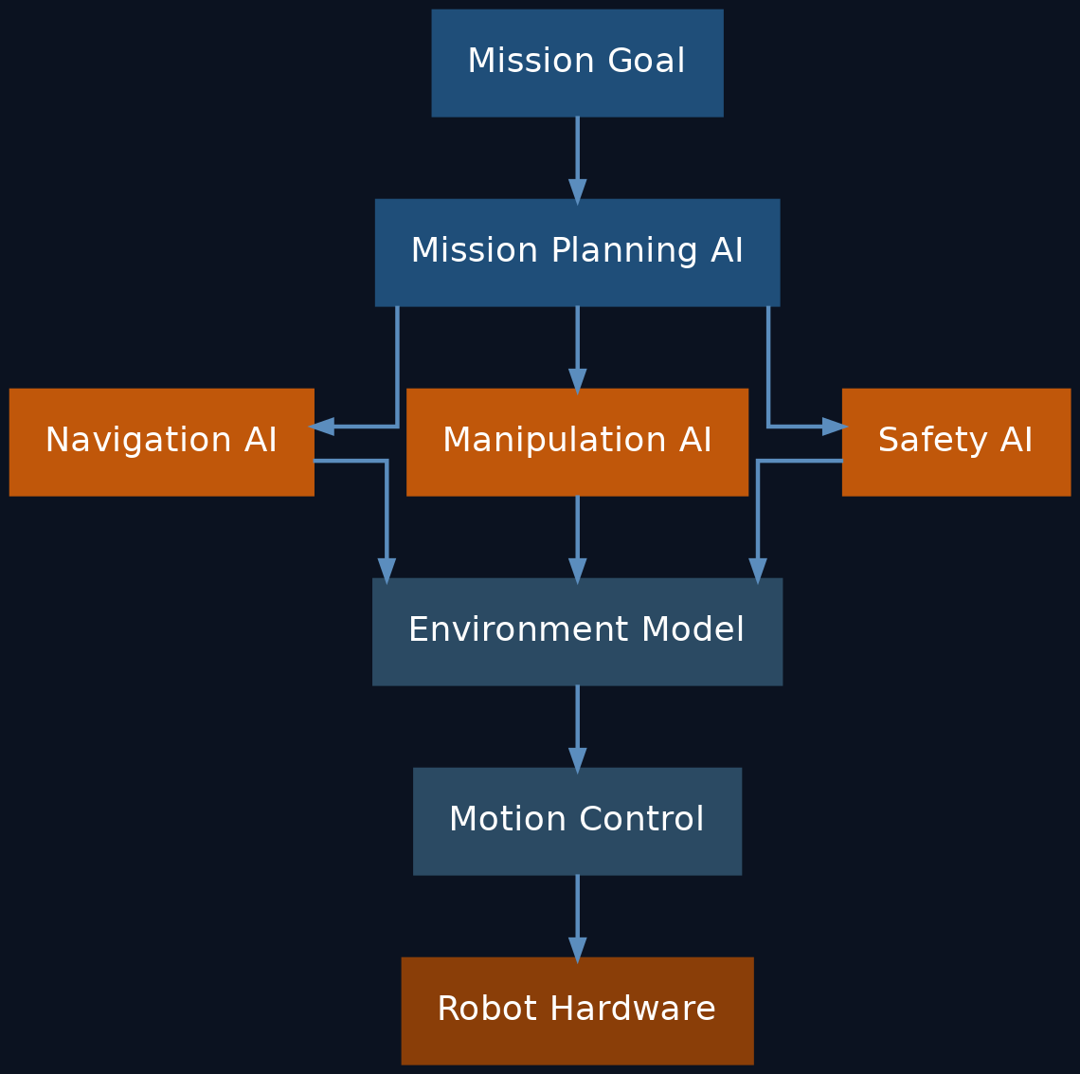
Fig. 4.1. Modular architecture of the avatar's artificial intelligence

4.4 Mission Planning AI
The first tier of AI. Its task is to translate the human's goal into a sequence of actions.
For example, the operator sends the command:
"Survey the southern part of the crater."
Mission Planning AI breaks the task down:
- Build a map of the area.
- Choose a safe route.
- Identify interesting geological features.
- Plan sample collection.
- Hand off tasks to the specialized subsystems.

4.5 Navigation AI
The navigation module is responsible for:
- route planning;
- obstacle avoidance;
- terrain analysis;
- tip-over prevention;
- energy conservation.
Navigation must account for the characteristics of the Martian surface:
- sandy patches;
- large rocks;
- slopes;
- dust;
- limited visibility.
A closely related approach is already used in the AutoNav system on the Perseverance rover, which autonomously evaluates or drives roughly 88% of the distance it covers without direct operator involvement. [8][9]

4.6 Manipulation AI
This module controls the manipulators. For example:
- picking up a sample;
- opening a container;
- replacing a part;
- installing a solar panel;
- connecting a cable.
If a task cannot be performed safely, the system halts execution and requests new instructions.

4.7 Safety AI
Safety has the highest priority. Every task is checked before execution.
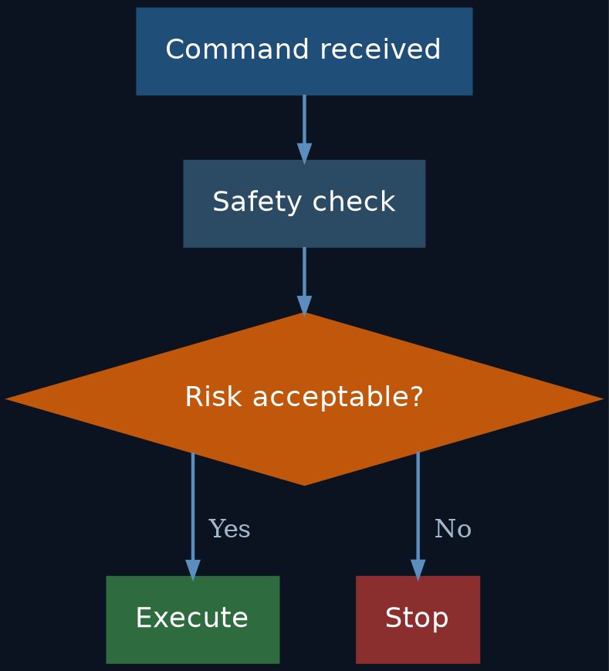
Fig. 4.2. Decision logic of the Safety AI module
The AI must not carry out actions that could damage equipment or endanger the mission as a whole.

4.8 Environment Model
Each robot maintains a digital model of its surroundings. It includes:
- a terrain map;
- the location of obstacles;
- equipment status;
- energy resources;
- weather conditions.
This model is continuously updated from sensor data.

4.9 Self-Learning
This concept does not assume that a robot autonomously modifies its core algorithms during a mission. This is an important engineering constraint.
During the execution of mission-critical tasks, it is preferable to rely on pre-validated models. Software updates should occur only after testing and confirmation by specialists.

4.10 Operation During Loss of Communication
If contact with Earth is lost, the robot does not continue performing complex tasks unsupervised. Possible responses:
- stop;
- switch to a safe mode;
- finish only the currently safe operation;
- save all data;
- wait for communication to be restored.
This behavior reduces the likelihood of equipment damage.

4.11 One Operator — Multiple Robots
As autonomy improves, a single operator will be able to oversee several specialized platforms, interacting not with each machine individually but with the overall control system:
Operator → Mission AI → Scientific Rover / Construction Robot / Drone / Cargo Robot

4.12 Limitations of Artificial Intelligence
Despite rapid progress, AI has limitations:
- errors in perceiving the environment;
- uncertainty in non-standard situations;
- dependence on sensor quality;
- limited ability to explain decisions;
- the need for thorough algorithm validation before use.
For this reason, within the project the AI is treated as a tool that supports mission execution, not as a fully independent explorer.

4.13 Chapter Conclusions
Artificial intelligence is a key element of the Mars Avatar Project architecture, since it allows the physically unavoidable Earth–Mars communication delay to be compensated for.
In the proposed concept, AI does not replace the human but provides autonomous execution of local actions within the goals and constraints that have been set in advance. This approach combines the strengths of human decision-making with the capabilities of modern autonomous robotic systems, and it is consistent with current trends in space robotics.

Chapter 5. Interplanetary Communication and Mission Control
“In interplanetary exploration, communication is not simply a channel for transmitting information—it is a fundamental architectural constraint.”

5.1 Role of the Communication System
In traditional robotics, communication provides an exchange of data between the operator and the machine. In an interplanetary setting, its role is much broader. The communication system must provide:
- transmission of mission goals;
- receipt of scientific data;
- monitoring of equipment status;
- coordination of multiple robots;
- safe operation under long delays.
The communication architecture becomes one of the key elements of the entire mission.

5.2 Physical Constraints
The distance between Earth and Mars is constantly changing. As a result, signal travel time is approximately:

Distance | One-way delay
Minimum | ~4 minutes
Average | ~12 minutes
Maximum | ~22 minutes

These values are set by the speed of light and cannot be eliminated by improving equipment. [4][5]
Consequently, the Mars Avatar Project architecture is built around this fundamental characteristic.

5.3 Communication Architecture
Each layer performs its own function and does not duplicate the others.
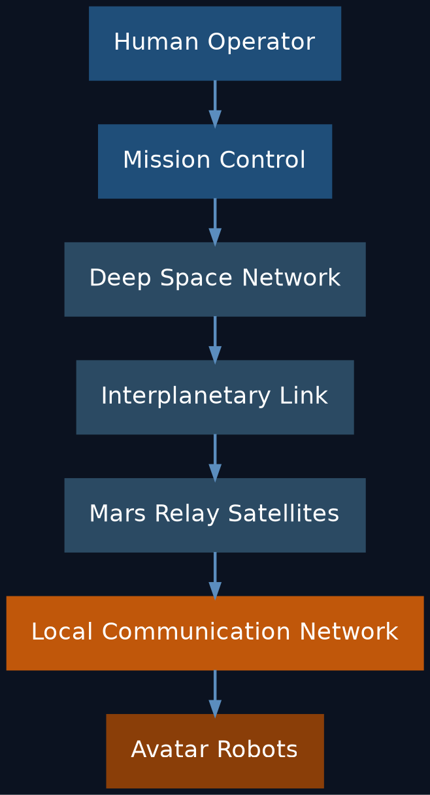
Fig. 5.1. Layers of the Mars Avatar Project communication system

5.4 Mission Control Center
Mission Control is the intelligent coordination hub. Its tasks:
- distributing tasks among robots;
- analyzing incoming data;
- planning operations;
- managing resources;
- interacting with the science team;
- preparing new commands.
Mission Control works with goals, not with the individual movements of each robot.

5.5 Mars Relay Network
Orbital relays make it possible to:
- increase surface coverage;
- reduce the likelihood of losing contact;
- enable data exchange between robots;
- store part of the information until the link is restored.
As the infrastructure develops, the number of relays can increase. [6][7]

5.6 Local Network on Mars
After data is received by the orbital assets, communication continues within a local network. It can connect:
- rovers;
- construction robots;
- drones;
- laboratories;
- power stations;
- future crewed bases.
In this way, a distributed robotic infrastructure is formed.

5.7 Command Transmission
Instead of continuous control, a packet-based principle is used. A command contains:
- a goal;
- constraints;
- a priority;
- an allowable execution time;
- criteria for successful completion.
For example:
Mission Goal: Collect Rock Sample · Location: Sector B12 · Priority: High · Safety: Maximum · Return Data
Once it receives such a packet, the local AI plans its execution independently.

5.8 Transmission of Scientific Data
Data returned to Earth includes: images, terrain maps, spectral measurements, telemetry, AI reports, and event logs. Transmission can occur at different priority levels.
High priority:
- emergency messages;
- equipment status;
- critical scientific discoveries.
Low priority:
- archival images;
- operation logs;
- diagnostic information.

5.9 Operation During Loss of Communication
Communication may become temporarily unavailable for various reasons:
- solar interference;
- equipment malfunctions;
- orbital-geometry constraints.
In such cases, the system must:
- preserve current data;
- switch to a safe mode;
- complete only safe operations;
- wait for the link to be restored.
This reduces the likelihood of equipment loss.

5.10 Network Scaling
In the early stages, the system may consist of only a few robots. Later, the architecture allows expansion into a distributed network.
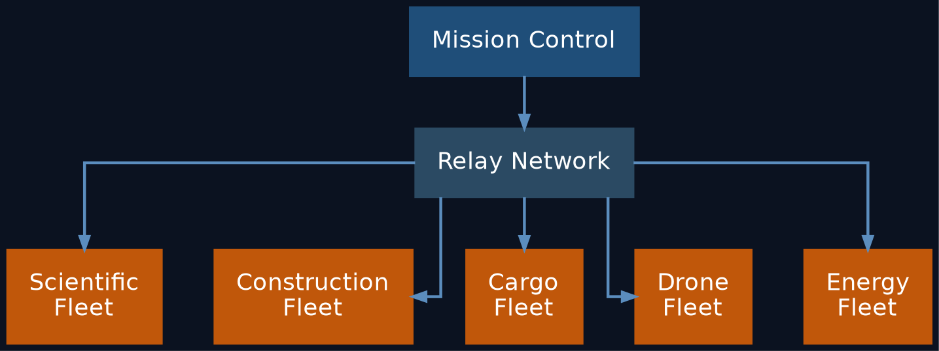
Fig. 5.2. Scaling of the distributed avatar network
All platforms operate as a single, coordinated system.

5.11 Cybersecurity
The interplanetary network must provide:
- command authentication;
- protection against data spoofing;
- packet integrity verification;
- redundant communication channels;
- logging of critical actions.
Security is treated as an integral part of the architecture, not as an add-on feature.

5.12 Chapter Conclusions
The communication system in the Mars Avatar Project is not merely a means of transmitting information — it is the foundation of the entire control architecture.
Because of the fundamental constraint imposed by the speed of light, control is built around the principle "goal → autonomous execution → feedback." This approach makes effective use of the combination of human decision-making and the autonomous operation of robotic systems.

Chapter 6. Robotic Avatars
“The robot is not intended to replace the explorer. It is intended to become the explorer's physical presence where the human body cannot safely operate.”

6.1 General Concept
At the heart of the Mars Avatar Project is the idea of specialized robotic platforms — avatars — each designed to carry out a particular class of tasks.
Rather than building a single universal robot, the project envisions a modular ecosystem in which different types of platforms work together and complement one another.
This approach is widely used in modern engineering, since specialized systems are often more effective than universal ones.

6.2 Basic Requirements
Every robotic avatar must possess the following characteristics:
- a high degree of autonomy;
- radiation resistance;
- a modular design;
- the ability to receive remote software updates;
- a self-diagnostic system;
- a safe operating mode for loss of communication;
- compatibility with the project's shared infrastructure.

6.3 Classes of Robotic Platforms

Scientific Rover
The primary research platform.
Functions:
- geological research;
- drilling;
- sample collection;
- spectral analysis;
- mapping;
- ice prospecting.
Equipment:
- manipulator arm;
- high-resolution cameras;
- lidar;
- spectrometers;
- drilling module;
- navigation sensors.

Construction Avatar
Purpose: building infrastructure.
Capabilities:
- installing solar arrays;
- assembling structures;
- assembling modules;
- laying cables;
- preparing sites.
This is one of the key elements in building a future base.

Cargo Robot
Designed for logistics. Main functions:
- transporting equipment;
- delivering spare parts;
- moving samples;
- moving construction materials.

Drone
Aerial vehicles can perform:
- reconnaissance;
- mapping;
- route-finding;
- equipment inspection;
- monitoring the condition of objects.
Given the thin Martian atmosphere, their design must account for the particular conditions of flight there.

Laboratory Unit
An autonomous laboratory performs:
- chemical analysis;
- biological analysis;
- sample preparation;
- long-term storage of materials;
- transmission of research results.

Maintenance Robot
Purpose: repairing other robots.
Functions:
- diagnostics;
- module replacement;
- equipment cleaning;
- maintenance.
This extends the operational life of the entire system.

6.4 Modular Design
Each avatar is built from interchangeable modules.
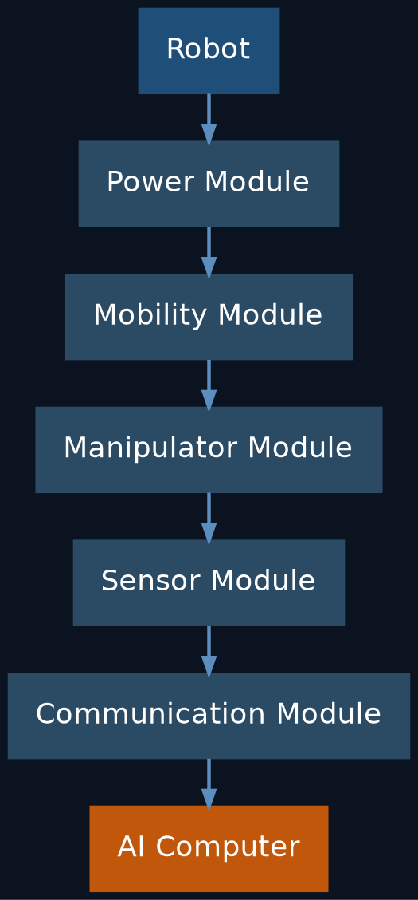
Fig. 6.1. Modular structure of a robotic avatar
This approach simplifies repair and upgrading.

6.5 Power System
Power sources may include:

Solar Panels
Advantages:
- high reliability;
- no consumable fuel;
- simplicity of operation.
Disadvantages:
- dependence on sunlight;
- the effect of dust storms.

Radioisotope Power Sources
Advantages:
- stable operation;
- independence from time of day.
Disadvantages:
- limited availability;
- complexity of development and use.
The specific choice depends on the type of mission and its power requirements.
NASA's own experience illustrates this choice: the solar-powered Opportunity rover was lost in 2018 to a global dust storm, while Curiosity and Perseverance, equipped with an MMRTG radioisotope power source, have continued operating regardless of sunlight or dust conditions. [10][11][12]

6.6 Sensor System
Every avatar must be able to perceive its environment. A possible sensor suite includes:
- stereo cameras;
- lidar;
- radar;
- spectrometers;
- temperature sensors;
- inertial navigation;
- manipulator force sensors.
The combined operation of these sensors makes it possible to build a digital model of the environment.

6.7 Self-Diagnostics
Each robot continuously monitors:
- battery charge;
- component temperature;
- motor status;
- link quality;
- computing-system errors.
When a fault is detected, the system can:
- limit functionality;
- switch to a safe mode;
- notify the operator;
- request maintenance.

6.8 Robot Collaboration
Collective work by specialized platforms is considered the most effective approach. For example:
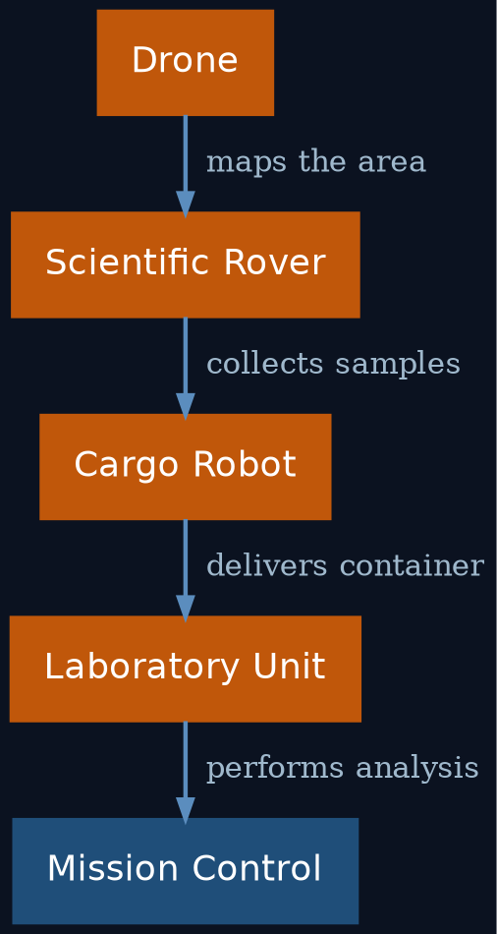
Fig. 6.2. Example of collaborative work among specialized platforms
Each unit performs its own function.

6.9 Scaling
The architecture allows for gradual growth.
Stage | Structure
Stage 1 | 1 operator → 1 robot
Stage 2 | Mission Control → 5 specialized robots
Stage 3 | Mission Control → 100 autonomous platforms
Stage 4 | Planetary Robotic Infrastructure → thousands of interacting systems

This makes it possible to expand capability without changing the underlying architecture.

6.10 Limitations
Robotic systems also have limitations:
- mechanical wear;
- dust-related damage;
- extreme temperatures;
- power constraints;
- the need for periodic maintenance.
The project therefore does not treat robots as fail-proof systems. Reliability is achieved through redundancy, modularity, and serviceability.

6.11 Chapter Conclusions
Robotic avatars form the physical layer of the Mars Avatar Project architecture. Rather than building a single universal machine, the concept envisions specialized platforms united by a shared control system and autonomous AI.
Modularity, distributed functionality, and the ability to scale gradually make it possible to adapt the architecture to a wide range of tasks — from scientific research to preparing infrastructure for future crewed expeditions.

Chapter 7. Human–Machine Interface: From Traditional Control to Telepresence
“The quality of exploration depends not only on the intelligence of the robot, but also on how naturally a human can interact with it.”

7.1 Introduction
One of the central challenges of the Mars Avatar Project is creating an effective form of interaction between the human and the robotic system.
Unlike traditional remote control, in which the operator controls every movement of the robot, the proposed concept envisions the transmission of goals and intentions rather than individual motor commands.
This requires interfaces that let a human quickly understand what is happening and interact effectively with the system even under a large communication delay.

7.2 Evolution of Control Interfaces
Development is proposed to proceed in stages.

Fig. 7.1. Evolution of interfaces for human interaction with the avatar

Stage 1 — Current Technologies
Used:
- keyboard and mouse;
- game controllers;
- professional joysticks;
- touch panels;
- voice control.
These technologies are already widely used in robotics and industry.

Stage 2 — Immersive Control
Additionally used:
- VR headsets;
- AR interfaces;
- spatial controllers;
- hand-motion tracking;
- eye tracking.
The operator gains a more natural sense of the working environment.

Stage 3 — Brain–Computer Interface (BCI)
As technology matures, neural interfaces may become usable. It is important to emphasize:
The Mars Avatar Project does not assume that current BCI technology is capable of fully replacing traditional means of control.
For the foreseeable future, they are regarded as a supplementary channel of interaction.

7.3 Brain–Computer Interface
A BCI is a system that allows signals from the nervous system to be used to interact with a computer. Today there are two main approaches.

Non-Invasive BCI
Examples:
- EEG;
- functional near-infrared spectroscopy (fNIRS);
- combined neural interfaces.
Advantages:
- no surgical intervention required;
- safety;
- accessibility.
Disadvantages:
- limited accuracy;
- low data transfer rate. [13][14]

Invasive BCI
Involve placing electrodes within neural tissue. Potential advantages:
- higher bandwidth;
- lower latency;
- more precise recognition of intent.
However, such systems are still at the research stage and require further development and safety evaluation. [13][14]

7.4 Telepresence
Telepresence does not mean creating the illusion of being on Mars in real time; it means giving the operator the most complete possible picture of events, given the unavoidable communication delay.
The operator receives:
- images;
- three-dimensional maps;
- telemetry;
- analysis results;
- AI reports.
This makes it possible to make well-informed decisions even when the data arrives with a delay.

7.5 The Role of Virtual Reality
VR can be used for:
- planning operations;
- training operators;
- simulating missions;
- analyzing the environment;
- visualizing routes.
The virtual environment itself is built from data received from Mars.

7.6 Haptic Feedback
In the future, devices that convey sensations of touch or resistance could be used.
Such technologies could improve task precision, but their use under an interplanetary delay requires further research.

7.7 The Operator's Role
In the proposed architecture, the operator:
- formulates the goal;
- analyzes incoming data;
- evaluates the AI's proposals;
- approves mission-critical actions;
- adjusts the mission as needed.
In this way, the operator remains the director of the process rather than the direct executor of every movement.

7.8 Limitations
Even as interfaces improve, objective limitations remain:
- communication delay;
- limited channel bandwidth;
- possible signal-recognition errors;
- cognitive load on the operator;
- the need for training on the system.
These limitations must be taken into account when designing the interface.

7.9 Development Roadmap
Stage | Capabilities
Today | Joysticks, keyboard, voice control, VR
5–10 years | Tighter VR integration, eye tracking, improved interfaces
10–20 years | High-bandwidth BCI as a supplementary interaction channel
Long-term | More natural forms of human–robot interaction (contingent on further scientific breakthroughs)

7.10 Chapter Conclusions
The human–machine interface is the connective link between the operator and the Mars Avatar Project's robotic infrastructure. The concept envisions a gradual evolution: from current control tools to more natural forms of interaction, including prospective neural interfaces.
At the same time, the fundamental constraint imposed by the Earth–Mars signal delay remains. Even the most advanced interfaces therefore do not remove the need for autonomous operation by the local AI; instead, they serve as tools for more effective goal-setting, data analysis, and human decision-making.

Chapter 8. Implementation Roadmap (Technology Roadmap)
“A vision becomes an engineering project only when it is divided into achievable steps.”

8.1 The Principle of Phased Development
The Mars Avatar Project does not envision building the complete system in a single step.
The concept is based on the gradual development of technology, where each successive level builds on the results of the previous one. This approach makes it possible to:
- test hypotheses experimentally;
- reduce technical risk;
- make use of already-existing technologies;
- adapt the architecture as new solutions emerge.

Fig. 8.1. Implementation stages of the Mars Avatar Project

8.2 Stage I — Concept Demonstration (2026–2030)
Goal:
Validate the core principles of the Mars Avatar Project under terrestrial conditions.
Main tasks:
- developing the software architecture;
- building a mission control center;
- integrating a VR interface;
- using existing robots;
- simulating a communication delay of 20–30 minutes;
- testing autonomous AI.
Demonstration scenario:
The operator is located in a laboratory. The robot operates at a remote test site. All commands pass through an artificial delay. The AI independently:
- plans a route;
- avoids obstacles;
- performs the assigned task;
- returns a report.
Result: creation of the first experimental prototype of the architecture.

8.3 Stage II — Lunar Demonstration (2030–2035)
Following successful terrestrial trials, the system can be adapted for use on the Moon.
Why the Moon?
- a much shorter distance;
- the possibility of more frequent missions;
- existing international exploration programs;
- relatively simple logistics.
At this stage it becomes possible to test:
- autonomous navigation;
- control of multiple robots;
- infrastructure construction;
- long-duration system operation.

8.4 Stage III — First Robotic Missions on Mars (2035–2045)
At this stage, the architecture is applied directly on Mars. Possible tasks:
- building landing pads;
- preparing power infrastructure;
- building storage facilities;
- geological research;
- scouting sites for future bases.
The operator is now managing not a single robot but the entire mission.

8.5 Stage IV — Robotic Infrastructure
As experience accumulates, individual platforms are joined into a single network. Possible elements:
- power stations;
- automated warehouses;
- repair stations;
- transport hubs;
- science laboratories;
- autonomous construction complexes.
This effectively creates the planet's first robotic infrastructure.

8.6 Stage V — Support for Crewed Missions
Once the infrastructure is in place, safer crewed expeditions become possible. By this point, robots can:
- prepare a landing site;
- deploy solar power plants;
- check equipment;
- build up resource stockpiles;
- prepare living modules.
As a result, the first crews arrive in an already partially prepared environment.

8.7 Long-Term Outlook
In the longer term, the same architecture could be adapted for other objects in the Solar System:
- the Moon;
- Phobos;
- Deimos;
- Europa;
- Titan;
- asteroids.
It should be stressed that this is a direction for further research, not a finished mission plan.

8.8 Technology Readiness
Component | Maturity Level
Robotic platforms | High
Interplanetary communication | High
Autonomous navigation | Medium–High
Local AI | Medium
Multi-robot systems | Medium
Non-invasive BCI | Medium
High-bandwidth BCI | Low–Medium
Full telepresence | Long-term goal

This table is not an official TRL assessment; it presents a qualitative classification of technology maturity within the concept.

8.9 Success Criteria
Each stage should conclude with an objective verification of results. Example criteria:
Stage I
- the robot completes a task under an artificial communication delay;
- the AI operates safely without operator involvement.
Stage II
- multiple robots coordinate joint work;
- the reliability of the architecture is confirmed.
Stage III
- successful autonomous operation on Mars;
- completion of scientific tasks;
- confirmed equipment reliability.

8.10 Key Risks
At every stage it is necessary to account for:
- technical constraints;
- AI reliability;
- power supply;
- communication delay;
- development cost;
- the effects of the Martian environment.
For this reason, moving to the next stage is only possible after the successful completion of the previous one.

8.11 Chapter Conclusions
The Mars Avatar Project is conceived as a long-term research and development program rather than a single mission. The proposed roadmap allows the key elements of the architecture to be tested sequentially — from a terrestrial prototype to a robotic infrastructure capable of supporting future crewed expeditions.
Each stage is based on the principle of gradually reducing uncertainty: new technologies are introduced only after experimental validation of the previous ones. This approach is consistent with the practice of large engineering programs and makes the concept more realistic and open to discussion.

Chapter 9. Analysis of Risks, Limitations, and Ethical Aspects
“Every ambitious engineering concept must be evaluated not only by its potential, but also by its risks and limitations.”

9.1 Introduction
Any architecture for an interplanetary robotic system faces a wide range of technical, organizational, and ethical challenges.
The purpose of this section is not to prove the project's absolute feasibility, but to identify the key constraints that must be taken into account as it develops further.
It is precisely an understanding of these constraints that turns a concept into an engineering research program.

9.2 Technical Risks

Equipment Reliability
The Martian environment differs substantially from Earth's. Main factors:
- dust storms;
- extreme temperatures;
- radiation;
- mechanical wear;
- limited repair capability.
Equipment must therefore be designed for high fault tolerance and the capacity for autonomous diagnostics.

Power Supply
Any autonomous system depends on power. Main risks:
- declining efficiency of solar panels;
- dust accumulation;
- battery degradation;
- failure of power modules.
The power system must therefore include redundancy and a range of power sources depending on the mission's requirements.

AI Failure
AI can:
- misinterpret a situation;
- make an error classifying objects;
- choose a suboptimal route;
- encounter a situation absent from its training data.
For this reason, critical decisions must remain under human control, and autonomous actions must be confined to predefined limits.

9.3 Communication Risks
Communication between Earth and Mars can be disrupted for various reasons:
- solar activity;
- hardware failures;
- damage to relay satellites;
- data transmission errors.
The architecture must provide for:
- command buffering;
- local data storage;
- a safe mode;
- automatic recovery once the link is restored.

9.4 Software Risks
Modern autonomous systems consist of millions of lines of code. Possible problems:
- programming errors;
- faulty updates;
- component incompatibility;
- accumulation of computational errors.
To reduce this risk, it is recommended to use:
- a modular architecture;
- independent testing;
- redundancy of critical components;
- formal verification of individual algorithms where feasible.

9.5 Cybersecurity
Although interplanetary systems are less accessible to outside interference, security remains an important concern. It is necessary to provide:
- cryptographic protection of commands;
- operator authentication;
- protection of telemetry;
- logging of actions;
- version control of software.
Security must be treated as part of the architecture from the very start of development.

9.6 Limitations of the Concept
It is important to note the limitations of the project itself. The Mars Avatar Project does not claim that:
- current AI is capable of fully replacing humans;
- existing BCI technology provides full telepresence;
- all the necessary technologies are already available.
On the contrary, the document offers a research roadmap that shows which components already exist and which require further development.

9.7 Ethical Questions
The development of autonomous robotic systems raises a number of questions. For example:
- What degree of autonomy is acceptable?
- Which decisions must always be approved by a human?
- Who is responsible for the system's errors?
- How can transparency in AI decision-making be ensured?
Within the Mars Avatar Project, the following principle is proposed:
The human retains responsibility for strategic decisions, while autonomous systems act only within predefined rules and goals.

9.8 Economic Risks
Building such an architecture will require:
- long-term research;
- international cooperation;
- substantial financial resources;
- the development of space infrastructure.
The project should therefore be regarded as a long-term research program rather than a short-term commercial initiative.

9.9 Scientific Limitations
Many elements of the project have not yet been experimentally confirmed. For example:
- scalable multi-robot systems for interplanetary conditions;
- long-duration autonomous operation without human involvement;
- widespread use of high-bandwidth BCI in space missions.
The following are therefore required:
- experimental prototypes;
- terrestrial trials;
- lunar demonstration missions;
- gradual validation of the architecture.

9.10 The Principle of Engineering Honesty
One of the core principles of the Mars Avatar Project is an open distinction between technologies based on their level of readiness:
🟢 Established | Existing Technologies — existing, proven solutions.
🟡 Projected | Projected Technologies — anticipated directions of development.
🔴 Long-Term | Long-Term Research — ideas that require fundamental scientific breakthroughs.

This approach helps avoid inflated expectations and makes the concept more transparent to the scientific community.

9.11 Chapter Conclusions
Any concept for exploring Mars must account not only for its potential benefits but also for its limitations.
The Mars Avatar Project treats risk as an integral part of the engineering process. Rather than attempting to ignore complexity, the project proposes staged hypothesis testing, gradual technology development, and continuous safety assessment.
This approach is consistent with the practice of developing complex technical systems, where reliability is achieved through sequential verification of solutions rather than an assumption of infallibility.

Chapter 10. Conclusion and Outlook
“The greatest advances in exploration begin not with certainty, but with a well-founded question.”

10.1 Summary of the Study
The Mars Avatar Project presents a conceptual architecture for robotic exploration of Mars, built on a combination of human decision-making, autonomous robotics, artificial intelligence, and interplanetary communication.
The project does not propose replacing humans with robots, nor does it treat autonomous systems as a standalone alternative to crewed expeditions.
Instead, it proposes a new approach in which intelligent robotic avatars become an extension of human presence, making it possible to carry out a wide range of tasks in conditions where continuous human presence carries high risk.

10.2 Key Findings
This study has produced several key conclusions.
1. Limitations of Crewed Missions
Present-day expeditions to Mars face objective challenges:
- cosmic radiation;
- flight duration;
- the need for life support;
- high cost;
- communication delay.
These constraints call for exploring additional architectures for planetary exploration.
2. Autonomy Is a Necessity
Because of the fundamental limit imposed by the speed of light, real-time control of robots is impossible.
Local artificial intelligence therefore becomes not an optional feature but a mandatory element of any interplanetary robotic system.
3. The Human Remains in Charge
Throughout the architecture, the principle of Human in Command is preserved. The human:
- defines the goals;
- makes strategic decisions;
- analyzes scientific results;
- oversees critical operations.
The AI carries out tasks strictly within the constraints that have been set.
4. The Architecture Must Evolve Gradually
The concept envisions sequential development:
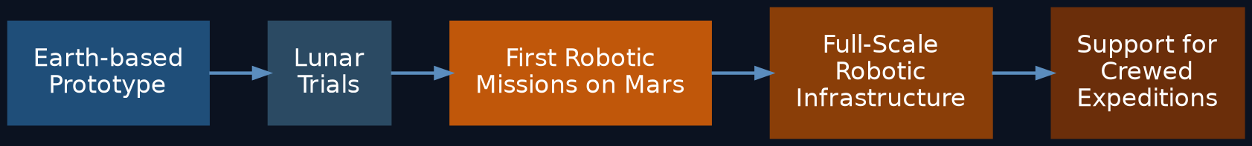
Fig. 10.1. Sequence of development for the Mars Avatar Project architecture
This path reduces technical risk and allows each hypothesis to be tested progressively.

10.3 The Scientific Value of the Project
The Mars Avatar Project is not a finished engineering solution.
Its main value lies in proposing a coherent architecture that brings together several actively developing fields:
- robotics;
- autonomous systems;
- artificial intelligence;
- space communication;
- human–machine interfaces.
The document proposes not a single technology, but a system of interaction among these components.

10.4 Possible Directions for Further Research
Future stages could include:

Robotics
- new types of avatars;
- modular platforms;
- autonomous repair.

Artificial Intelligence
- more reliable planning;
- collective coordination among robots;
- explainable AI;
- formal verification of algorithms.

Interfaces
- improved VR systems;
- adaptive interfaces;
- advances in neural interfaces.

Space Communication
- new relay networks;
- optimized data exchange;
- intelligent information routing.

Experimental Research
- terrestrial test sites;
- artificial communication delay;
- long-duration autonomous trials;
- lunar demonstration missions.

10.5 Long-Term Vision
In the more distant future, a similar architecture could be applied not only on Mars. The concept is potentially scalable to:
- the Moon;
- asteroids;
- Europa;
- Titan;
- other objects in the Solar System.
However, such scenarios require separate research and are not treated as an immediate goal of this document.

10.6 A Closing Thought
The history of human exploration has always been accompanied by the creation of new tools.
Ships made it possible to cross oceans. Airplanes shortened the distances between continents. Computers expanded the reach of human thought.
Robotic avatars may become the next stage in this evolution — a tool that will let humans explore other planets while keeping the decisions in their own hands.

Conclusion
The Mars Avatar Project is a conceptual study of a possible architecture for future interplanetary robotic systems.
The document does not claim that the system described already exists or could be implemented in the near term. Rather, it seeks to show a coherent development path grounded in existing technologies, promising research directions, and open scientific questions.
The project's main goal is to encourage discussion, interdisciplinary collaboration, and further research into the robotic exploration of space.
The future of planetary exploration may depend not only on where humans can travel, but on how effectively human intelligence can be extended through intelligent machines.

Appendix A. Sources and References
The sources below support the key technical claims made in this document. The bracketed numbers in the chapter text ([1], [2], etc.) refer to the corresponding entries in this list. This list does not claim to be an exhaustive scientific survey; it should be treated as a starting point for further verification.

For Chapter 2. The Challenge of Exploring Mars
[1] ESA, "The radiation showstopper for Mars exploration" — an overview of cosmic radiation risk for long-duration missions, including data from the ExoMars Trace Gas Orbiter and NASA's Twins Study. esa.int
[2] Cucinotta F.A., Kim M.Y., Chappell L., "How Safe Is Safe Enough? Radiation Risk for a Human Mission to Mars," PLOS ONE, 2013 — a quantitative estimate of the risk of exposure-induced death (REID) from cancer for a Mars mission, based on NASA's model. Available via PubMed Central (PMC3797711).
[3] Cucinotta F.A., Durante M., "Cancer risk from exposure to galactic cosmic rays: implications for space exploration by human beings," The Lancet Oncology, 2006, 7: 431–435.
[4] NASA, ASCEND / NTRS, "Communication Delays, Disruptions, and Blackouts for Crewed Mars Missions" — an analysis of communication delay (up to ~22 minutes one-way) and full signal-blackout periods during solar conjunction. ntrs.nasa.gov (20220013418).
[5] ESA, Mars Express Blog, "Time delay between Mars and Earth" — an illustration of the minimum (~4 min) and maximum (~24 min) signal delay. blogs.esa.int/mex.

For Chapters 3 and 5. Architecture and Interplanetary Communication
[6] NASA Science, "Mars Relay Network" — a description of the currently operating network of relay orbiters (Mars Reconnaissance Orbiter, Mars Odyssey, MAVEN, ESA's Trace Gas Orbiter, Mars Express) and their role in transmitting data from the Martian surface. science.nasa.gov/mars/mars-relay-network.
[7] NASA/JPL, "The Mars Relay Network Connects Us to NASA's Martian Explorers" — a technical description of the Deep Space Network and the scheme for relaying commands and telemetry through orbiting spacecraft. jpl.nasa.gov.

For Chapter 4. Artificial Intelligence and Autonomous Navigation
[8] Verma V. et al., "Autonomous robotics is driving Perseverance rover's progress on Mars," Science Robotics, 2023 — data on the share of autonomously driven distance (88% of 17.7 km in the rover's first Martian year) and AutoNav's performance records. doi.org/10.1126/scirobotics.adi3099.
[9] NASA/JPL, "NASA's Self-Driving Perseverance Mars Rover 'Takes the Wheel'" — a description of how AutoNav works: building 3D terrain maps, detecting hazards, and planning routes without operator input. jpl.nasa.gov.

For Chapter 6. Avatar Power Systems
[10] NASA/JPL, "Mars 2020 Perseverance Launch Press Kit — Power" — technical specifications of the MMRTG radioisotope power source (about 110 W at the start of the mission, a design life of 14 years). jpl.nasa.gov.
[11] Scientific American, "Why NASA's Perseverance Mars Rover Uses Nuclear Energy" — a comparison of MMRTG power with solar panels, and a discussion of the Opportunity rover, which was lost to the 2018 dust storm.
[12] Marspedia, "Radioisotope Thermoelectric Generators: Advantages and Disadvantages" — a comparison of radioisotope power sources with solar panels, including the effect of "dust devils" on the solar arrays of the Spirit and Opportunity rovers.

For Chapter 7. Neural Interfaces (BCI)
[13] Waldert S., "Invasive vs. Non-Invasive Neuronal Signals for Brain-Machine Interfaces: Will One Prevail?," Frontiers in Neuroscience, 2016 — a comparison of invasive and non-invasive neural-signal acquisition methods in terms of resolution, bandwidth, and risk. PMC4921501.
[14] "Brain–computer interfaces in 2023–2024," review article, Brain-X, Wiley, 2025 — a current review of the trade-off between accuracy and invasiveness in modern BCI systems. onlinelibrary.wiley.com.

Note
This list reflects the state of technology and scientific data at the time this document was prepared and requires periodic updates as new publications appear. All quantitative estimates (TRL levels, risk percentages, equipment specifications) should be verified against primary sources before use in presentations or publications intended for a technical audience.

